# CS 255 System Design Document Template

Danica Hesemann

## UML Diagrams

### UML Use Case Diagram

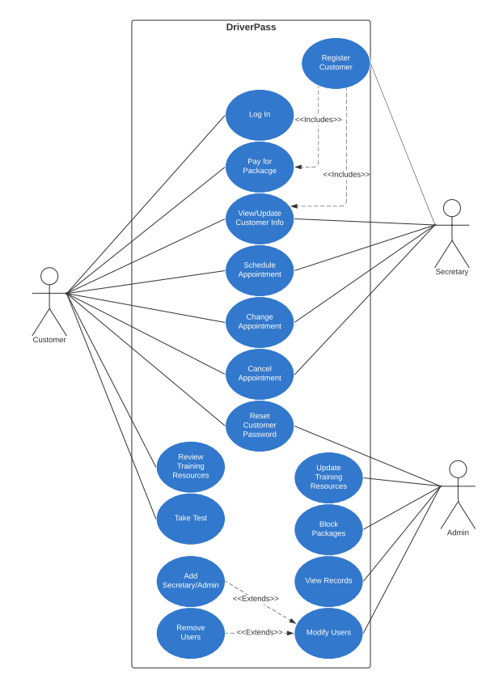

### UML Activity Diagrams

Register User

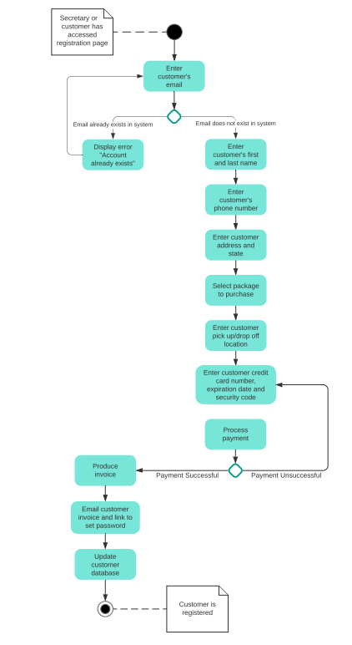

Schedule Appointment

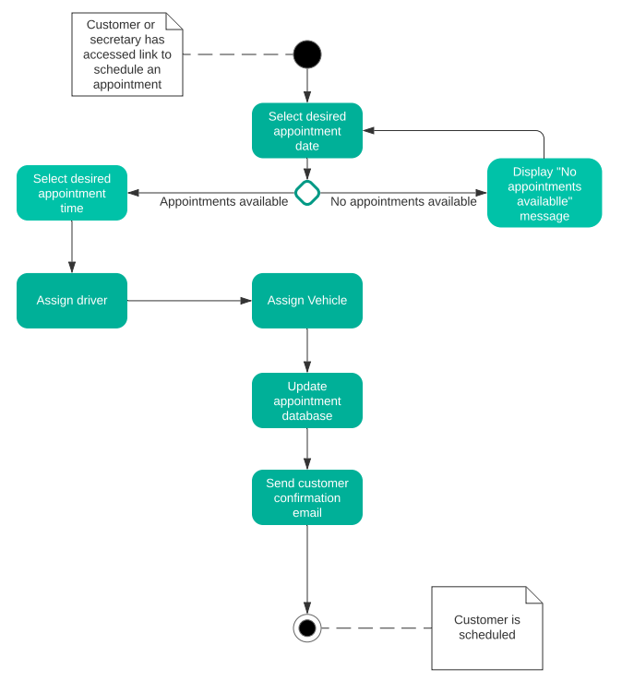

### UML Sequence Diagram

Register User

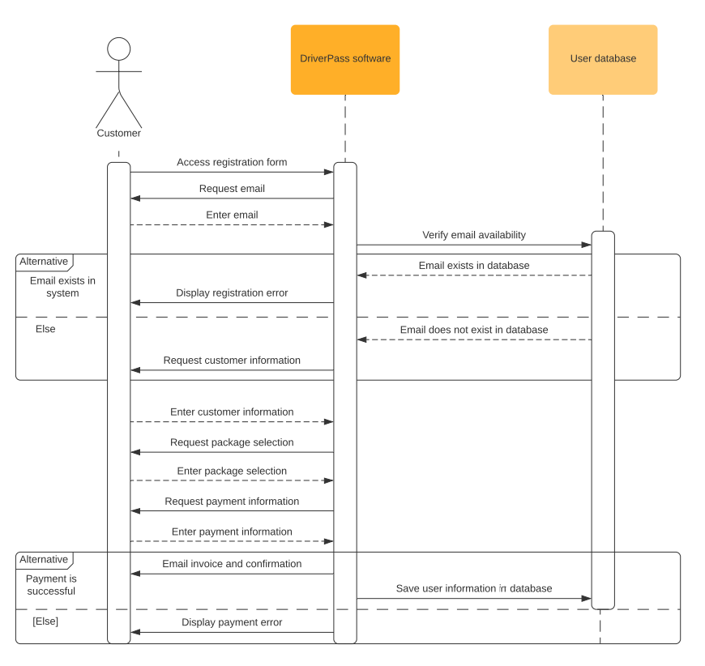

### UML Class Diagram

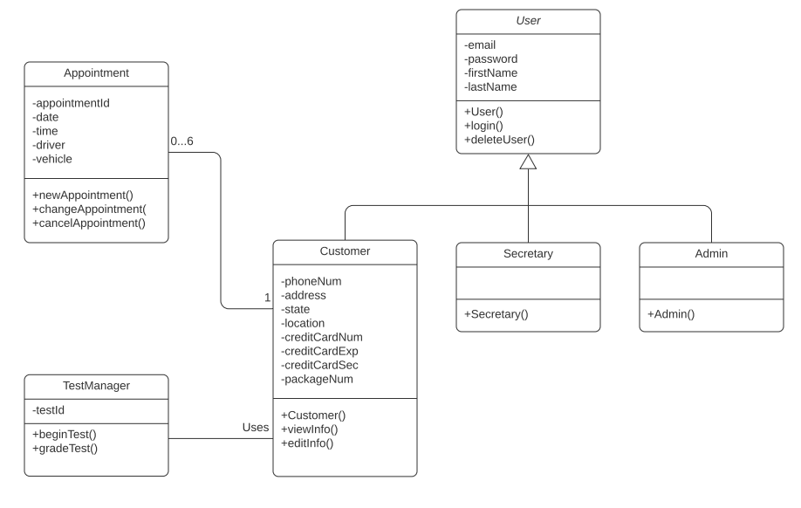

## Technical Requirements

* The client and customers will need a computer or mobile device to access the system.
* The client will need a cloud-based server to host the system.
* The client and customers will need internet access to use the system.
* The system software will need to be deployed for the client to access the system.
* The client will need a database software package to store information in databases.
* The client will need to install security software to protect the system and the data within it.
* The client will need a physical store to act as a base of operations.
* The client will need vehicles for on-the-road training.
* The client will need a parking lot to keep their vehicles.